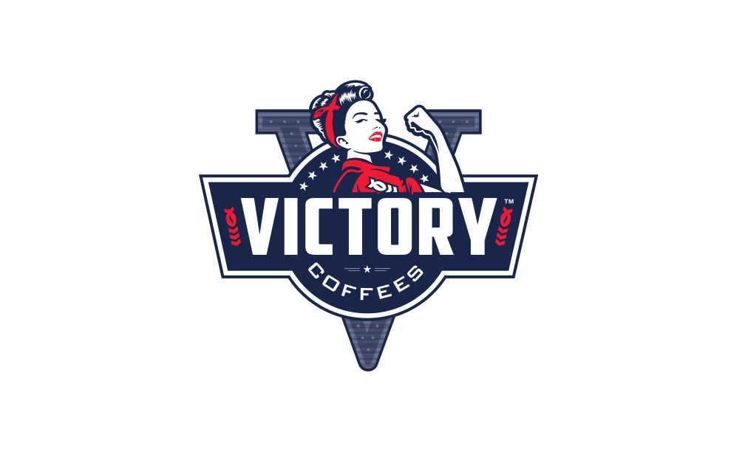
VICTORY COFFEES VOLUME PRICING – January 14, 2017
“Your troops deserve 5-STAR coffee.”

Minimum order per: 35 x 12oz –or- 25 LB –or- 20 cases Soldier Cups

COFFEE Blend 12Oz PER LB

ADMIRAL Espresso $7.99 $10.99

LEATHERNECK Dark $7.99 $10.99

SAILOR Medium $7.99 $10.99

TROOPER Light $7.99 $10.99

AIRMAN Decaf/Light $7.99 $10.99

SOLDIER CUPS Espresso 30 count @ $15.99/box
(K cups)

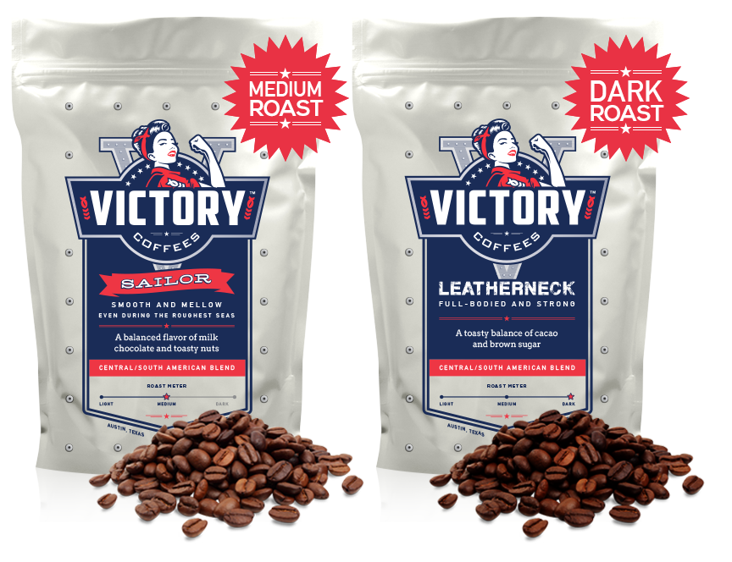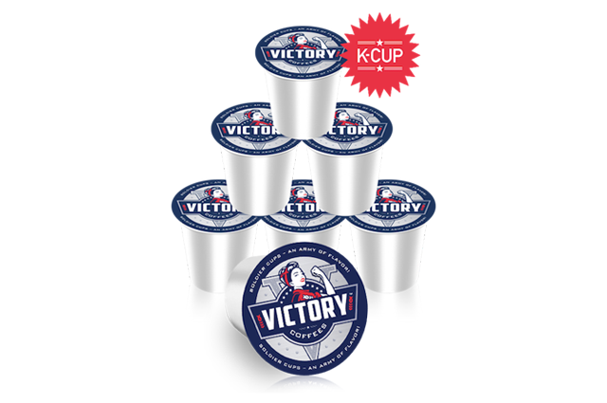

Start your day with a VICTORY!

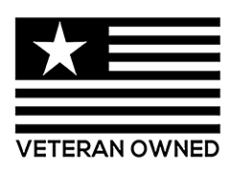

www.VICTORYcoffees.com

